Report by: Berni Saldias
027 235 9731
bsaldias@farmright.co.nz
Report for: LUDF
Date: 30th April 2025
Visit Date: 29th April 2025

 | 29th April 2025  CURRENT | 25th March 2025  Last Month
Total cows on farm | 510 | 558
Cows Milkers | 500 | 541
Penicillin / colostrum | 10 | 16 (3 out of the vat)
Springer/MT,CO cows | 26 empties/6 culls | 1 dry
Milksolids: per day | 587 kgMS * | 836 kgMS *
per cow | 1.17 kgMS/cow | 1.51 kgMS/cow
per ha | 3.82 kgMS/ha | 5.22 kgMS/ha
Somatic cell count | 167,000 | 130,000
Average pasture cover | 2394 kgDM/ha | 2490 kgDM/ha
Pre-grazing covers | 3400 kgDM/ha | 3350 kgDM/ha
Post-grazing covers | 1480 - 1500 kgDM/ha | 1550 kgDM/ha
Effective area in round | 160 ha | 160 ha
Stocking rate | 3.18 cows/ha | 3.48 cows/ha
*kgMS is the average of the last 7 days
Cows
- 38 light cows will be dried off on Wednesday.
- Continue monitoring cow condition, and don’t hesitate to dry off another group of light young and early calvers if required.
- Stock rec:
  - Current cows on-farm 510 cows
  - Less 26 empties
  - Less 6 must cull
  - Total MA 478 in-calf cows
  - Plus R2 94 in-calf cows
  - Total 571 in-calf cows
  - Note: the above calculation does not take into account the slips

Pasture
- The round length ranges between 35-38 days based on 160ha effective of 4.2-4.5ha/day.
- Current feed demand is 48 kgDM/ha/day at 15kgDM intake with grass demand at 38kgDM/ha/day while feeding 3kg/baleage.
- Recent growth rate was 51kgDM/ha/day.
- Pasture covers are lower than measured, most likely due to lower dry matter content on the grass.
- Use post-grazing residuals as guidance to continue supplementing with baleage.
  - So far 404kgDM/cow has been used.
- Look to get rid of the empties (26) and culls (6-7) as soon as possible, especially if you need to continue supplementing the cows after the current wet weather event.
- Use the attached Autumn feed budget as guidance for the APC. However, consider the discrepancy between observed/measured covers and what the cows are telling you.
- Continue cleaning up any clamps that have not been grazed down to 1,550kgDM/ha whenever possible to set up the farm for next spring.

Milk Production
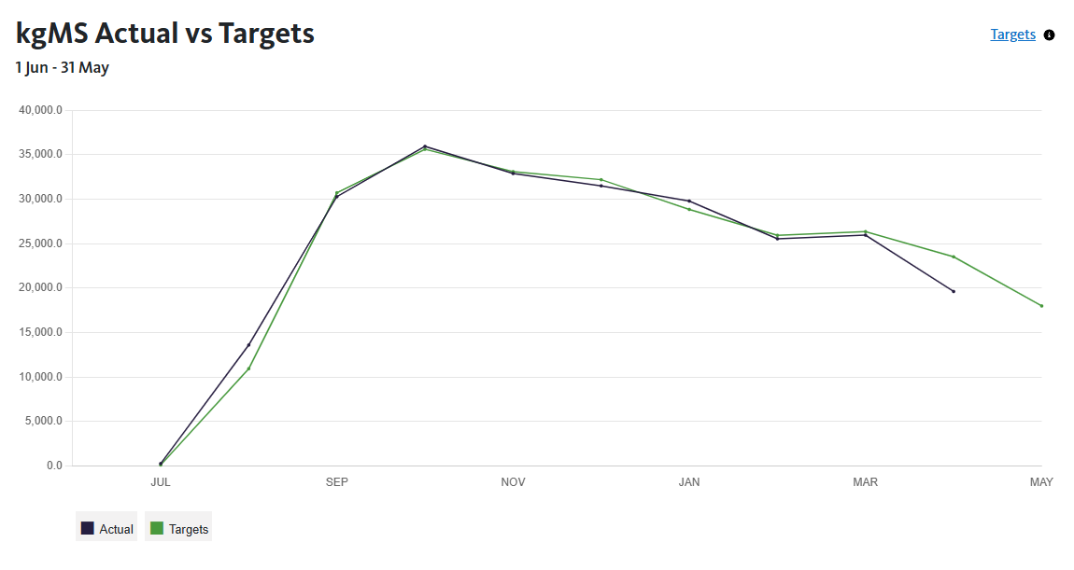
Total STD production: 245,434 kgMS (until the 29th April) vs 247,371 kgMS (budgeted to end of April).

Nitrogen / fertiliser
- An average of 174kgN/ha was used this season.

Any queries about this report or other issues please contact me.
Next scheduled visit: Friday 6th June at 1.00pm to visit the winter grazing block including R2.
Regards,
Berni Saldias
FarmRight Limited Consultant

