Report by: Berni Saldias
027 235 9731
bsaldias@farmright.co.nz
Report for: LUDF
Date: 11th November 2025
Visit Date: 11th November 2025

 | 11th November 2025  CURRENT | 21st October 2025  Last Month | 18th November 2024  Last Season
Total cows on farm | 548 | 550 | 558
Cows Milkers | 548 | 554 | 551
Penicillin/ colostrum |  | 6 | 7
Springer/MT,CO cows | - |  | -
Milk solids: per day | 1100 kg MS | 1179 kg MS | 1100 kg MS *
per cow | 2.01 kg MS/cow | 2.12 kg MS/cow | 1.99 kg MS/cow *
per ha | 6.87 kg MS/ha | 7.36 kg MS/ha | 6.87 kg MS/ha
Somatic cell count | 116,000 | 113,000 | 138,000
Average pasture cover | 2408 kg DM/ha | 2442 kg DM/ha | 2439 kg DM/ha
Pre-grazing covers | 3400 kg DM/ha | 3250 kg DM/ha | 3100 kg DM/ha
Post-grazing covers | 1500 -1550kgDM/ha | 1550 kg DM/ha | 1580 kg DM/ha
Effective area in round | 146.28 ha | 146.2 ha | 146.28 ha
Stocking rate | 3.76 cows/ha | 3.76 cows/ha | 3.81 cows/ha

Cows and Mating
- 23 cows are on OAD.
- PSM: 23rd October
  - 478 cows (based on MINDA records) have been submitted in the first 13 days, which equals 87.2% of the herd.
  - The industry target is 90% of the herd submitted in the first 3 weeks, which equals to 493 cows.
  - 70 cows haven’t been mated; this includes some late calvers that still need time to cycle.
  - The true non-cycling cows will be checked by the Vet this week.

Regrassing
- Paddock S9 will be sprayed off as soon.
  - The plan is to nip it off after the withholding period, and apply N.
- Paddock N10 is tracking well.
- Both paddocks will be back in the round once they are nipped off, hopefully, within the next 2.5-3 weeks.

Pasture
- Current round length is 21 days based on 146 ha effective of 6.9 ha/day.
- Current feed demand is 73 kg DM/ha/day (based on an estimated intake of 19.5 kg DM/cow/day).
- Recent growth rate was 94 kg DM/ha/day.
- With the strong APC and pre-grazing covers above demand, the plan is to take 12.3ha out for baleage.
- When you have dropped paddocks out for baleage, stay on the same m²/cow/day. This will, in effect, speed the rotation length up.
- At the current stocking rate, maintain a 21-day rotation to ensure cows achieve post-grazing residuals and that pasture does not lose quality through becoming stemmy.
- Area allocation and pre-grazing targets for 21-day rotation on 146ha (160 ha less 13.72 ha for regrassing).
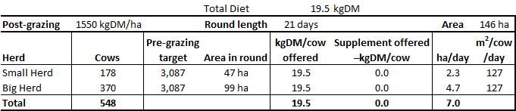
- And any pre-grazing covers above 3100kgDM/ha should be considered surplus.
- Having a rotation length greater than this will result in the pre-grazing covers becoming too high, making it challenging to maintain pasture quality and round length.
- If post-grazing residuals are higher than the target, consider:
  - Cutting baleage.
  - Topping selected paddocks, especially where the residual had been left high in previous rotations.
- Once the new grass is back in the round, consider reverting to a 22-day round length.
- Area allocation and pre-grazing targets for 22-day rotation on 160ha.
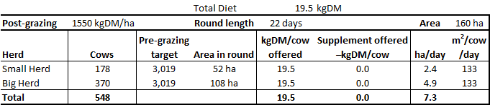
- This will have a grass demand of 67 kg DM/ha/day.
- Any pre-grazing covers above 3020 kg DM/ha should be considered surplus.
- Consider the points below when post-grazing residuals are higher than the target:
  - Is cow demand lower than the target?
  - Is the pre-grazing cover above the target?
  - Is the allocated area correct?
  - Does area need to be taken out for silage?
- Cut silage little and often to avoid a lumpy wedge for next round.
- You can always come back a couple of days later to graze a paddock locked in for silage if the grass position gets tight.
- If pre-grazing covers are below target, offer supplement rather than speeding up the rotation length. Silage should be offered to ensure the cows always leave the targeted 1,550 kgDM/ha residuals.

Nitrogen / fertiliser
- Continue applying N as per the farm plan.

Any queries about this report or other issues please contact me.
Next scheduled visit: TBC

Regards,
Berni Saldias
FarmRight Limited Consultant

