Report by: Berni Saldias
027 235 9731
bsaldias@farmright.co.nz
Report for: LUDF
Date: 17th March 2026
Visit Date: 17th March 2026

 | 17th March 2026  CURRENT | 25th March 2026  Last Season
Total cows on farm | 536 | 558
Cows Milkers | 529 | 541
Penicillin / colostrum | 7 reds | 16 (3 out of the vat)
Springer/MT,CO cows |  | 1 dry
Milksolids: per day | 817 kgMS | 836 kgMS *
per cow | 1.54 kgMS/cow | 1.51 kgMS/cow
per ha | 5.10 kgMS/ha | 5.22 kgMS/ha
Somatic cell count | 131,000 | 130,000
Average pasture cover | 2371 kgDM/ha | 2490 kgDM/ha
Pre-grazing covers | 3400 kgDM/ha | 3350 kgDM/ha
Post-grazing covers | 1500 kgDM/ha | 1550 kgDM/ha
Effective area in round | 160 ha | 160 ha
Stocking rate | 3.35 cows/ha | 3.48 cows/ha

Cows
- Milk solid per cows was estimated based on the last 2 days’ pick-up.
- Individual body condition has been scheduled for this coming Friday.
- Any at-risk cows should be dried off early, as per the Info Vet report.
- At-risk cows include early light calvers and second calvers. Late calvers have more time over winter to gain condition.
- The table below summarises the estimated dry-off timeline (adjusted from DairyNZ) required to reach the calving BCS target for cows fed autumn pasture only:
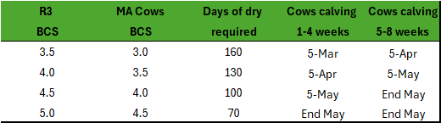

Pasture
- Estimated round length is 30 days based on 160ha effective of 5.3ha/day.
- Current feed demand is 58kgDM/ha/day based on 17.5kgDM intake, with grass demand at 44kgDM/ha/day while feeding on average 4.3kgDM/cow of baleage.
- Recent growth rate was 59kgDM/ha/day.
- The feed wedge currently indicates a false surplus, with only one paddock above pre-grazing demand while the rest of the feed wedge is in deficit.
- Baleage utilisation has been excellent. Consider increasing allocation if cows are still grazing down to 1500kgDM/ha residuals.
- Gradually extend rotation length to capture potential pasture growth rates as growth slows:
  - 1st April 35 days
  - 20th April 40 days Final round
- Current situation: Area allocation and pre-grazing targets for 30-day rotation on 160ha, using 4.3kgDM/cow/day of baleage.
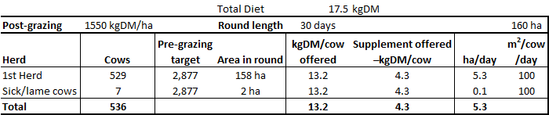
- Area allocation and pre-grazing targets for 35-day rotation on 160ha and feeding 3kgDM /cow/day of baleage.
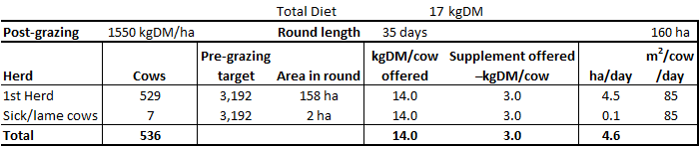
- Area allocation and pre-grazing targets for 40-day rotation on 160ha, with 78 culls gone and feeding 2kgDM/cow/day of baleage.
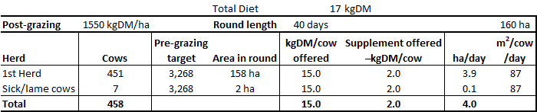
- If residuals or pre-grazing covers fall below targets offer baleage rather than speeding up the round length, this will protect the APC.
- Look to clean up the clamps that have not been grazed down to 1,550kgDM/ha to set up the farm for next spring. Graze them down before the farm becomes too wet.
- If pre-grazing covers aren’t to target through the autumn, consider the following options:
  - Cull low-producing and high SCC empty cows earlier
  - Increase supplementation
  - Cull all remaining empty cows

Nitrogen / fertiliser
- Check the N application per paddock to ensure enough room to apply N in April.
- All N applications should be finished by the end of April or once soil conditions aren’t suitable to apply (too wet or soil temperatures below 8˚C).

Any queries about this report or other issues please contact me.
Next scheduled visit: Tuesday 21st April at 9.00am.
Regards,
Berni Saldias
FarmRight Limited Consultant

