Report by: Berni Saldias
027 235 9731
bsaldias@farmright.co.nz
Report for: LUDF
Date: 20 May 2026
Visit Date: 19 May 2026

 | 19 May 2026  CURRENT | 21 April 2026  Last Month
Total cows on farm | 450 | 522
Cows Milkers | 286 | 482
Penicillin / colostrum | 7sick mob | 2reds/33lames)
Springer/MT,CO cows | 157 dries | 5 dries
Milksolids: per day | 442kgMS | 702 kgMS
per cow | 1.30kgMS/cow | 1.36 kgMS/cow
per ha | 2.76 kgMS/ha | 4.38 kgMS/ha
Somatic cell count | 149,000 | 132,000
Average pasture cover | 2073 kgDM/ha | 2306 kgDM/ha
Pre-grazing covers | 3000-3050kgDM/ha | 3244 kgDM/ha
Post-grazing covers | 1500-1550 kgDM/ha | 1560 kgDM/ha
Effective area in round | 160 ha | 160 ha
Stocking rate | 2.81 cows/ha | 3.26 cows/ha

Cows
- 32 culls left the farm today.
- 157 cows have been dried off so far.
- All cows will body condition scored next Monday.
- Dry off date is the 28 May.
- Final scan due this afternoon.
- Stock rec:
  - Current cows on-farm 450 cows
  - Less slips 3 cows
  - Plus R2 122 in-calf cows
  - Total 569 in-calf cows
- The current stock on hand will support a peak of 549 cows, assuming a 3.5% wastage between 1 June and 1 Dec.

Pasture
- There are another four paddocks (around 28ha) to be grazed from tomorrow to the end of the season.
- Last week allocation was 4.4ha/day, giving a 36-day round length.
- Current feed demand has been estimated at 45kgDM/ha/day. Grass silage is being fed to fill the feed wedge gap and protect post-grazing residuals to 1500-1550kgDM/ha.
- Recent growth rate was 30kgDM/ha/day.
- Cows have done a good work cleaning up paddocks. Continue grazing any remaining clumps down to 1450-1500kgDM/ha whenever possible to set up the farm well for next spring.

Wintering
- Focus on body condition gain during June by drafting cows based on age and body condition and feeding them according to demand
  - R3
  - Light cows
  - Good condition cows
- By early July, draft cows by calving dates
  - Early calvers
  - Mid calvers
  - Late calvers

Spring Rotation Planner
- The SRP has been set up for next season. I will not send the plan until early July, once we have reviewed the actual APC and made any final adjustments.
- Identify any poor quality baleage for use with the springer cows, particularly this season as the springers will stay at the dairy platform, where grass may have potentially higher K levels than at the East block.

Milk Production
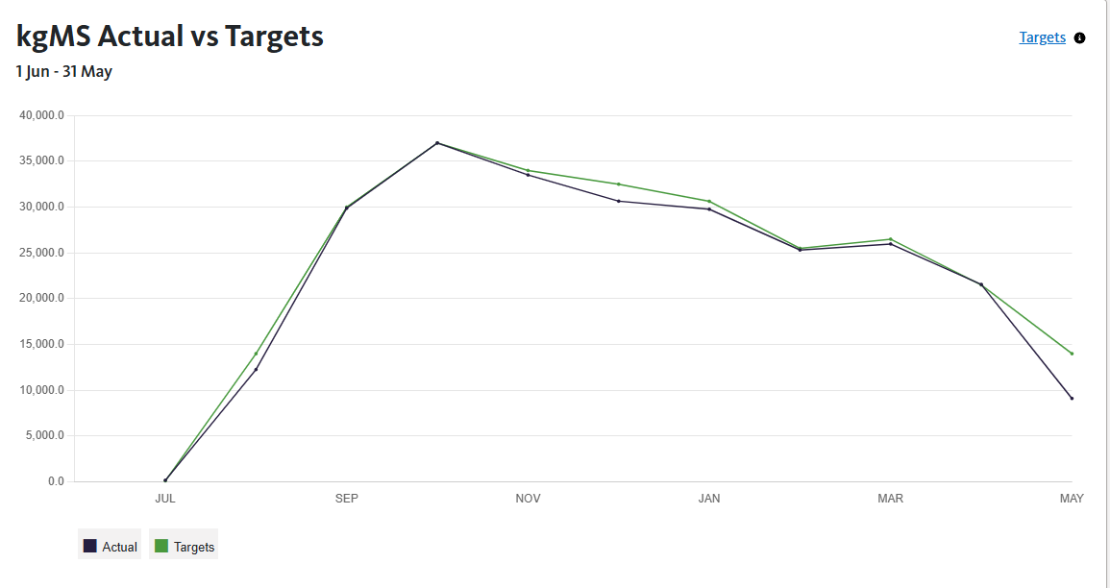
Total STD production: 255,195 kgMS (to 18 May) vs 264,756 kgMS budgeted
Total MTD production 9,115kgMS (to 18 May) vs 14,000kgMS (31 May)

Any queries about this report or other issues please contact me.
Next scheduled visit: TBC date: Visit to the winter grazing block including R2.
Regards,
Berni Saldias
FarmRight Limited Consultant

